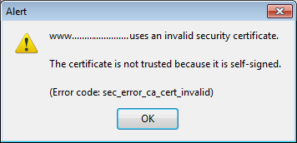

# cert_override.txt

<https://developer.mozilla.org/En/Cert_override.txt>

cert_override.txt is a text file generated in the user profile to store certificate exceptions specified by the user.  This file is used by Firefox, Thunderbird, and other XUL-based applications.

Since there is no way to add easily an exception in a XULRunner 1.9 project, you can open the page in Firefox, accept the certificate, then copy the cert_override.txt to the XULRunner application profile.

The syntax is described on [this web site](http://boblord.livejournal.com/18402.html).

### Example

Here is an example for a SHA1-256 hash algorithm. The key and the website are not valid:

# PSM Certificate Override Settings file

# This is a generated file! Do not edit.

some.website.com:443 OID.2.16.840.1.101.3.4.2.1 00:11:22:33:44:55:66:77:88:99:AA:BB:CC:DD:EE:FF:FF:EE:DD:CC:BB:AA:99:88:77:66:55:44:33:22:11:00 U AAAAAAAAAAAAAAABAAAAAAAAAAAAAAAAAAAAAAAAAAAAAAAAAAAAAAAAAAAAAAAA AAAAAAAAAAAAAAAAAAAAAAAAAAAAAAAAAAAAAAAAAAAAAAAAAAAAAAAAAAAAAAAA AAAAAAAAAAAAAAAAAAAAAAAA AAAAAAAAAAAAAAAAAAAAAAAAAAAAAAAAAAAAAAAA AAAAAAAAAAAAAAAAAAAAAAAAAA==

### Fields

Fields are separated by a tab character. Each line is terminated by a line feed character (UNIX format).

1. domainname:port : port 443 for HTTPS (SSL)
2. hash algorithm OID
   * SHA1-256: OID.2.16.840.1.101.3.4.2.1 (most used)
   * SHA-384: OID.2.16.840.1.101.3.4.2.2
   * SHA-512: OID.2.16.840.1.101.3.4.2.3
3. Certificate fingerprint using previous hash algorithm
4. One or more characters for override type:
   * M : allow mismatches in the hostname
   * U : allow untrusted certs (whether it's self signed cert or a missing or invalid issuer cert)
   * T : allow errors in the validity time, for example, for expired or not yet valid certs
5. Certificate's serial number and the issuer name as a base64 encoded string

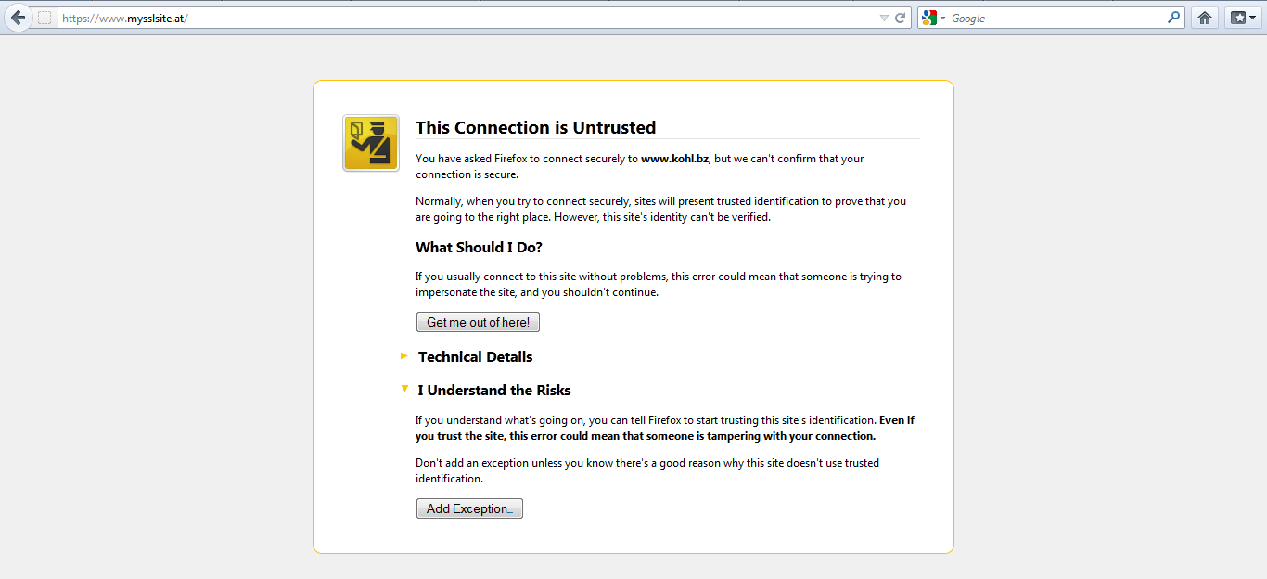

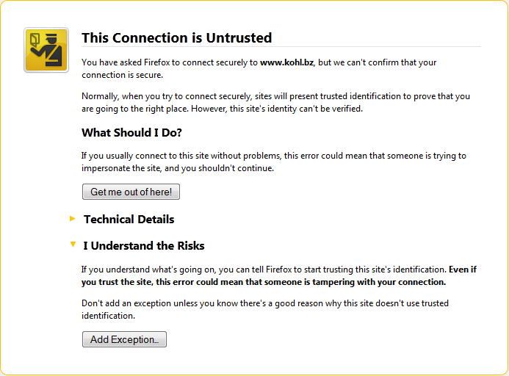

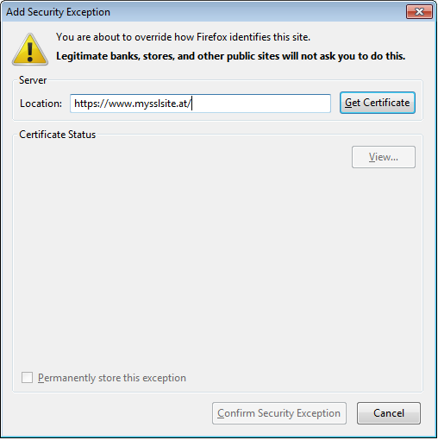

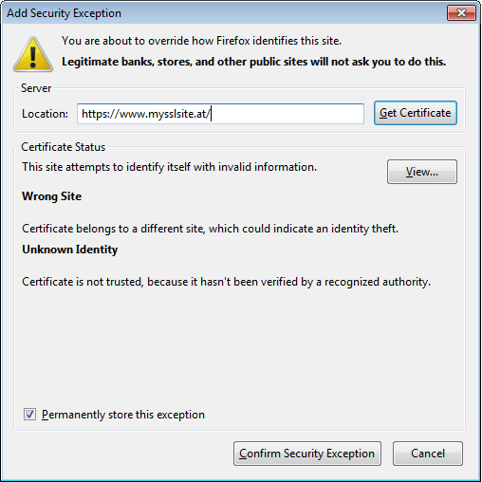

# Profile folder

<http://kb.mozillazine.org/Profile_folder>

Mozilla applications store a user's personal information in a unique profile. The first time you start any Mozilla application, it will automatically create a default profile; additional profiles can be created using the [Profile Manager](http://kb.mozillazine.org/Profile_Manager). The settings which form a profile are stored in files within a special folder on your computer — this is the *profile folder*. The installation directory also includes a "profile" folder but this folder contains program defaults, not your user profile data.

For information on the profile folder specific to certain applications, including how to find the profile folder, see the following articles:

* [Profile folder - Firefox](http://kb.mozillazine.org/Profile_folder_-_Firefox)
* [Profile folder - Thunderbird](http://kb.mozillazine.org/Profile_folder_-_Thunderbird)
* [Profile folder - Mozilla Suite / SeaMonkey](http://kb.mozillazine.org/Profile_folder_-_SeaMonkey)

For other applications, see the information below. Some of these folders may be hidden.

|  |  |
| --- | --- |
| **Operating system** | **Profile folder location(s)** |
| Windows NT (NT4.x/2000/XP/Vista/7) | "%APPDATA%\Mozilla\" |
| Windows 95 (without Desktop Update) | C:\Windows\Mozilla |
| Windows 95 (with Desktop Update)/98/Me | C:\Windows\Application Data\Mozilla\  C:\Windows\Profiles\<Windows login/user name>\Application Data\Mozilla\ |
| Unix/Linux | ~/.mozilla/ |
| Mac OS X | ~/Library/Mozilla/  ~/Library/Application Support/ |

[[edit](http://kb.mozillazine.org/index.php?title=Profile_folder&action=edit&section=1)]

### For Windows users

On Windows systems, the default location of the profile folder containing your user data is under the "Application Data" folder in Windows XP and below or under the "AppData\Roaming" folder in Windows Vista and above. In Windows 2000 and above, these folders are hidden. To find your profile folder in Windows 2000/XP/Vista/7:

Press [Windows Key]+[R] → Type in **%APPDATA%** → click OK

A Windows Explorer window will open, showing the contents of the *C:\Documents and Settings\<user name>\Application Data* folder (Windows 2000 and XP) or the *C:\Users\<user name>\AppData\Roaming* folder (Windows Vista and 7). You can then open successive folders until you get to the profile folder.

If you want to browse to the default profile folder locations for Windows 2000 or later you will need to enable viewing of hidden files and folders in your Windows Folder Options. You can also search for specific files in your profile folder using Windows Search. In Windows 2000 you must first enable viewing of hidden files and folders; in Windows XP and Vista, you must enable searching for hidden files and folders *in the Search tool itself.* If you need more help viewing or searching hidden files and folders in Windows 2000 or later, see [this article](http://kb.mozillazine.org/Finding_the_profile_folder_on_Windows).

[[edit](http://kb.mozillazine.org/index.php?title=Profile_folder&action=edit&section=2)]

## Write-protected files

Make sure that you do not have read-only or locked files in your profile, which might be a side effect of backing up the profile to removable media and then restoring your profile from that media. Having such write-protected files in the profile can result in serious problems, as described in [bug 257288](https://bugzilla.mozilla.org/show_bug.cgi?id=257288). Note that, on Windows, you can remove read-only attributes at the directory level for all subordinate folders and files, through the file properties of a folder.